

**Software Requirements Specification**

*COSC2299 Software Engineering: Process and Tools (2350)  
Group P7_7*

#### 

Team:

Ashley Mullin - s3937907

Clarence O'toole - s3943755

Jaspal Singh-Walia - s3899925

Manik Thapliyal - s3953664

Sri Kalyan Rohan - s3958905

Ramon Aguila - s3840883

Table of Contents:

Revision History 2

Wireframes 3

Product Page 3

Landing Page 4

Profile (My Orders) 5

Profile (Personal Information) 6

Profile (Account Settings) 7

Profile (Wishlist) 8

Item Page 9

Shopping Cart 10

Checkout 11

Architecture 12

User Stories 13

# Revision History

| **Name** | **Date** | **Reason for changes** | **Version** |
| --- | --- | --- | --- |
| Ramon | 19/08/23 | Removed product backlog,  sprint 1 and 2 backlog, and  sprint 0 retro. These are uploaded on GitHub as separate documents |  |

# Wireframes

## Product Page

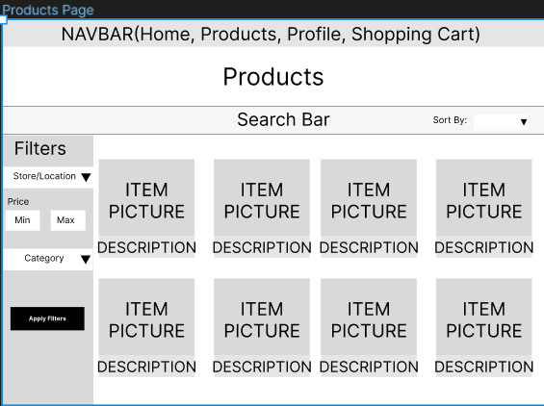

## Landing Page

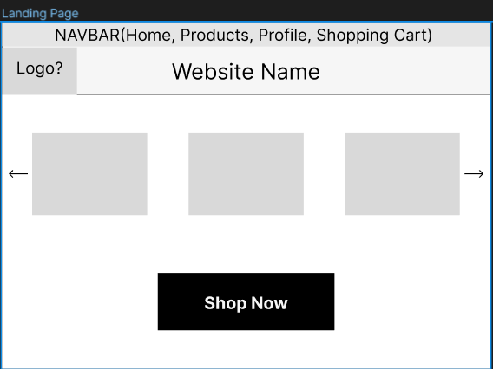

## Profile (My Orders)

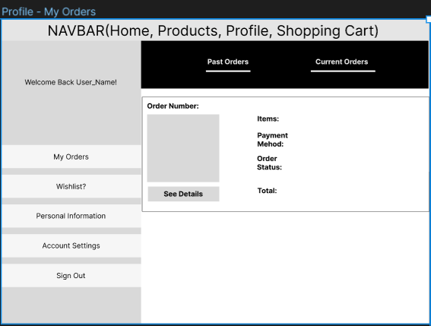

## Profile (Personal Information)

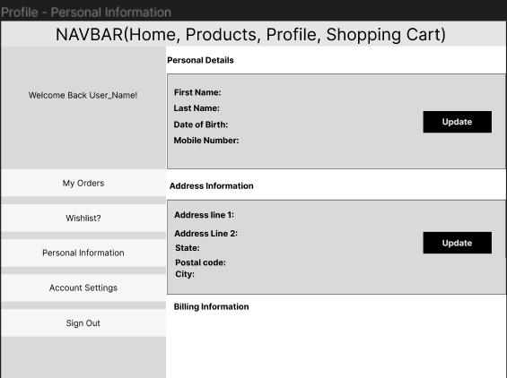

## Profile (Account Settings)

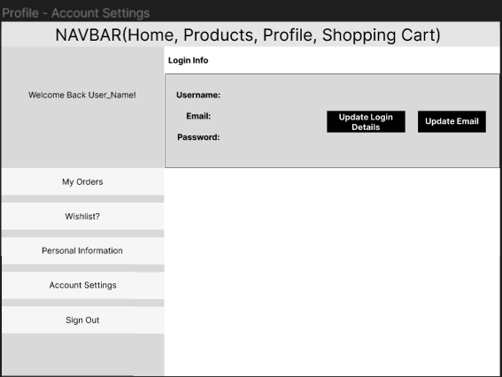

## Profile (Wishlist)

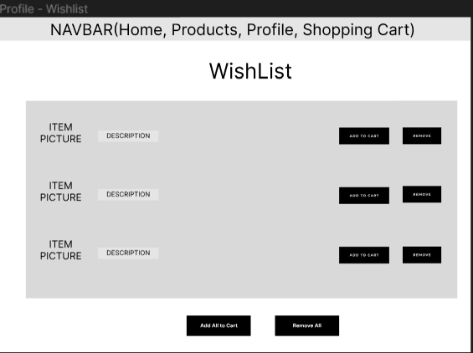

## Item Page

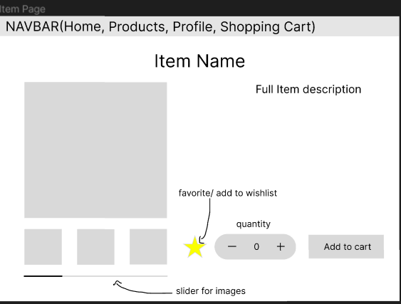

## Shopping Cart

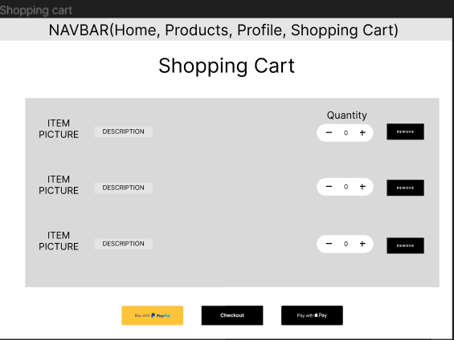

## Checkout

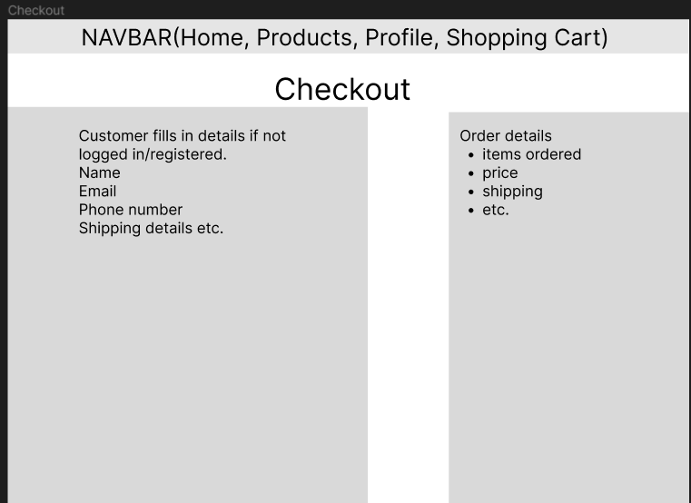

# Architecture

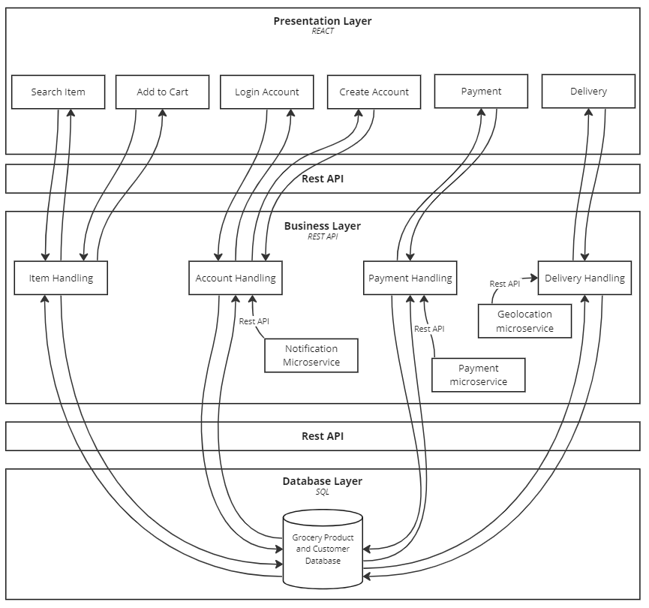

* **Search Item:** this component will allow the user to query the product database and return a list of relevant products.
* **Add to cart:** adds an item to a particular user’s cart.
* **Login account:** allows a user to login and access their personal account.
* **Create account:** new users can create a new account.
* **Payment:** prompts the user to pay for their order; choosing a select payment service.
* **Delivery:** will show delivery status for orders.
* **Item Handling:** will consult the item database depending on the user filters or will place items into the user’s cart.
* **Account handling:** will handle login information and relevant user information.
* **Payment handling:** will handle user payment and ensure the correct amount is charged.
* **Delivery handling:** will calculate delivery details; time, location, status.
* **Grocery product and customer database:** using SQL to store the data, it will contain all items such as cost and stock *and user reviews*, user information which will contain usernames and password, and transaction history.
* **Notification microservice:** this microservice is responsible for sending any notification to the corresponding user account on the website.
* **Payment microservice:** handles services such as PayPal that is a microservice.
* **Geolocation microservice:** responsible for getting user location in order to determine delivery costs and distance for all types of delivery options.

Rest API is used to communicate between layers of the system. This allows for a modular design which will increase security as there is no direct connection between presentation layer and database as well as making it easier to develop as no team requires the other to completely finish their feature to start implementing their feature.

# User Stories

**Definition of done**

* Code is written by multiple developers and/or peer reviewed
* Unit tests cover 80% of situations, and all tests pass
* Functional testing based on acceptance criteria pass
* Implemented feature is intuitive to use, and passes usability tests
* Code tested and verified to work on website browsers (Chrome and Firefox), using Windows
* Code contains no known bugs
* Code is well-documented
* Code approved by product owner

| **Story #1** | Search - Keywords | **Priority** | High |
| --- | --- | --- | --- |
| **Estimate** | 3 |
| As a | customer | | |
| I want to | search for a product using keywords, | | |
| So that | can quickly find the item I'm looking | | |
|  | | | |
| Acceptance criteria | **Scenario: Search with results**  Given I am on the products page and have entered keywords of the item in the search bar,  when the I click "search",  then the system will display products that include the keywords in the name, description or category.  **Scenario: Search with NO results**  Given I am on the products page and have entered the name of the item in the search bar and the item does not exist,  when the I click "search",  then the system will display to my screen an error message, saying that the product does not exist. | | |

| **Story #2** | Search - Category | **Priority** | High |
| --- | --- | --- | --- |
| **Estimate** | 3 |
| As a | customer | | |
| I want to | browse different categories | | |
| So that | can explore a range of offerings from stores close to me | | |
|  | | | |
| Acceptance criteria | **Scenario: Viewing the categories**  Given I am on the home page,  when I click 'Categories',  then the system will display a list of categories that the user can select from.  **Scenario: Selecting a category and displaying results**  Given I have the categories displayed,  when I click a category',  then the system will display all the items from the selected category. | | |

| **Story #3** | Search - Viewing an item | **Priority** | High |
| --- | --- | --- | --- |
| **Estimate** | 2 |
| As a | customer | | |
| I want to | view an item's information | | |
| So that | I can make an informed decision whether to purchase it | | |
|  | | | |
| Acceptance criteria | **Scenario: Displaying the item's information**  Given I entered a search and the system is displaying at least one item,  when I click on the item,  then the system will display the key information about the item.  key information includes: Name, description, stock availability, store and available delivery options.  **Scenario: Displaying updated information**  Given I entered a search and the system is displaying at least one item,  when I click on the item,  then the system will display the updated information about the item.  examples of information changes can include price, stock availability and delivery options. | | |

| **Story #4** | Sorting results by price | **Priority** | High |
| --- | --- | --- | --- |
| **Estimate** | 3 |
| As a | customer | | |
| I want to | sort the search results from cheapest to most expensive | | |
| So that | I can choose from the cheaper options first | | |
|  | | | |
| Acceptance criteria | **Scenario: Sorting the search results**  Given I entered a search that displays at least one item,  when I click 'Sort by Price',  then the system will sort the items in ascending order of price. (Lowest price first, highest price last) | | |

| **Story #5** | Cart | **Priority** | High |
| --- | --- | --- | --- |
| **Estimate** | 5 |
| As a | customer | | |
| I want to | view my cart, | | |
| So that | I can check what items I’m missing or need to remove before checking out. | | |
|  | | | |
| Acceptance criteria | **Scenario: Viewing an empty cart**  Given I am a registered user,  when I click 'Cart' on the navigation bar,  then the system will direct me to the 'Cart' page and display a message "The cart is currently empty".  **Scenario: Viewing cart with at least one item in it**  Given I am a registered user and I am on the homepage and I added at least one item in the cart,  when I click 'Cart',  then the system will direct the user to the 'Cart' page and display the items added to the cart.  **Scenario: Removing an item from the cart**  Given I am a registered user and I am on the 'Cart' page and there is at least one item in the cart,  when I click 'Remove item',  then the system will remove the selected item from the cart.  **Scenario: Editing quantity**  Given I am a registered user and I am on the 'Cart' page and there is at least one item in the cart,  when I click 'Edit' and enters a new number,  then the system will update the item quantity and total price accordingly. | | |

| **Story #6** | Adding an item to the cart | **Priority** | Medium |
| --- | --- | --- | --- |
| **Estimate** | 2 |
| As a | customer, | | |
| I want to | add an item to my cart | | |
| So that | purchase it together with other items | | |
|  | | | |
| Acceptance criteria | **Scenario: Adding a new item to the cart**  Given I am logged in to the website and I have an item page opened,  when I click 'Add to Cart',  then the system will add 1x item to the user's cart.  **Scenario: Adding an existing item to the cart**  Given I am logged in to the website and I have an item page opened and the item is already in the cart,  when I user click 'Add to Cart',  then the system will increase the item's quantity by one. | | |

| **Story #7.1** | Selecting delivery options | **Priority** | Medium |
| --- | --- | --- | --- |
| **Estimate** | 3 |
| As a | registered customer | | |
| I want to | be able to pick from a wide range of delivery options such as standard, express, and same-day | | |
| So that | I can select the best option that suits my needs | | |
|  | | | |
| Acceptance criteria | **Scenario: Delivery option drop-down**  Given I am on the 'Cart' page and I added at least one item in the cart,  when I click on 'Select delivery type',  then the system will display a drop down bar, showing the available delivery options based on the items in the cart.  **Scenario: Updating the delivery price**  Given I am on the 'Cart' page and I have the delivery options open,  when I click on a delivery option,  then the system will display the new delivery price and add it to the grand total. | | |

| **Story #7.2** | Selecting delivery options | **Priority** | Medium |
| --- | --- | --- | --- |
| **Estimate** | 3 |
| As a | registered customer | | |
| I want to | designate a preferred window of time for my delivery to arrive | | |
| So that | my delivery does not arrive when I am away from the house. | | |
|  | | | |
| Acceptance criteria | **Scenario: Displaying delivery time frames**  Given I am on the 'Cart' page and I selected a delivery option,  when I click 'Select delivery time frame',  then the system will display a list of available delivery time frames.  **Scenario: Selecting a delivery time frame**  Given I am on the 'Cart' page and the list of available delivery time frames are displayed,  when I select a time frame,  then the system sets the order's delivery time to the selected time frame. | | |

| **Story #8** | Checkout | **Priority** | Medium |
| --- | --- | --- | --- |
| **Estimate** | 3 |
| As a | customer | | |
| I want to | check out my order | | |
| So that | I can pay and receive the items I ordered | | |
|  | | | |
| Acceptance criteria | **Scenario: Check out - Success**  Given I am on the 'Cart' page and I added at least one item in the cart and I have selected a delivery option  when I click 'Check out',  then the system will direct me to the payment page.  **Scenario: Check out - No items in the cart**  Given I am on the 'Cart' page and the cart is empty,  when I click 'Check out',  then the system will display an error message, saying that my cart is empty.  **Scenario: Check out - Delivery option not selected**  Given I am on the 'Cart' page and the cart is empty,  when I click 'Check out',  then the system will display an error message, asking to select a delivery option.  **Scenario: Payment - Success**  Given I am on the 'Payment' page,  when I enter valid credentials,  then the system will process the order and display a message saying that my order has been placed.  **Scenario: Payment - Fail**  Given I am on the 'Payment' page,  when I enter invalid credentials,  then the system will display an error message, saying that the credentials entered are invalid. | | |

| **Story #9** | Notification preferences | **Priority** | Medium |
| --- | --- | --- | --- |
| **Estimate** | 2 |
| As a | customer | | |
| I want to | customise my notification preferences | | |
| So that | I can select what I receive notifications for | | |
|  | | | |
| Acceptance criteria | **Scenario: Accessing the notification preferences**  Given I am logged in and I am on the profile page,  when I click 'Notifications',  then the system will direct the user to the 'Notifications' page, displaying a list of notifications that can be toggled.  Notification items include promos, price drop on favorited items.  By default, all notifications will be turned off.  **Scenario: Turning on notifications**  Given I am logged in and I am on the 'Notifications' page,  when I click 'ON' for a notification,  then the system will update their preferences and send timely notifications accordingly.  **Scenario: Turning off notifications**  Given I am logged in and I am on the 'Notifications' page and a notification is turned on,  when the user clicks 'OFF' for a notification,  then the system will update their preferences and stop sending the user notifications. | | |

| **Story #10** | Notifications - Special offers | **Priority** | Medium |
| --- | --- | --- | --- |
| **Estimate** | 2 |
| As a | customer | | |
| I want to | promptly receive notifications about special offers | | |
| So that | I can take advantage of the promos before they expire | | |
|  | | | |
| Acceptance criteria | **Scenario: Receiving notifications**  Given I am logged in and I have notifications for special offers on,  when a store releases a promo,  then the system will send a timely notification to the user.  the notification will be displayed as a browser notification. | | |

| **Story #11** | Favoriting an item | **Priority** | Medium |
| --- | --- | --- | --- |
| **Estimate** | 2 |
| As a | customer | | |
| I want to | ‘favourite’ an item | | |
| So that | I can be notified when there is a promo or discount for the selected item | | |
|  | | | |
| Acceptance criteria | **Scenario: Favoriting an item**  Given I am logged in and I have the item page opened,  when I click the star button,  then the system will add the item into favourites and notify me when there is a promo or discount.  **Scenario: Un-favoriting an item**  Given I am logged in and the favorited item page opened,  when I click the star button,  then the system will remove the items from favourites and stop notifying me when there is a promo or discount. | | |

| **Story #12** | Registration | **Priority** | 3 |
| --- | --- | --- | --- |
| **Estimate** | Low |
| As a | new customer | | |
| I want to | create an account | | |
| So that | I can save my personal details for future purchases | | |
|  | | | |
| Acceptance criteria | **Scenario: Registering with new email**  Given I am not registered already registered on the website,  when I register with a new email,  then the system will create a new account with the inputted information.  **Scenario: New customer profile**  Given I am registering with a new email,  when I fill-in the form for creating a profile,  then the system will create the profile with the inputs from the form.  **Scenario: Existing customer**  Given I have already registered on the website,  when I register with my email,  then the system will display an error message saying that they already have an account, and display a hyperlink to the 'Log In' page. | | |

| **Story #13** | Logging in | **Priority** | Low |
| --- | --- | --- | --- |
| **Estimate** | 1 |
| As a | registered customer | | |
| I want to | log in to my account | | |
| So that | I can access my account and make purchases | | |
|  | | | |
| Acceptance criteria | **Scenario: Logging in with valid credentials**  Given I am on the login page and I have an existing account in the system,  when I enter a valid email address and password,  then the system will redirect me to the homepage, displaying my username on the top right corner.  **Scenario: Wrong password**  Given I am on the login page and I have an existing account in the system,  when I enter an incorrect password,  then the system will display an error message, saying that the password is wrong.  **Scenario: Email is not registered**  Given I am on the login page and I do not have an existing account in the system,  when I enter an unregistered email and password,  then the system will display an error message, saying that the email does not have an account yet, and display a hyperlink to the registration page. | | |

| **Story #14** | Personal details (Profile) | **Priority** | Low |
| --- | --- | --- | --- |
| **Estimate** | 1 |
| As a | registered customer | | |
| I want to | edit my personal details (name, address etc.) | | |
| So that | I can quickly check out my future purchases | | |
|  | | | |
| Acceptance criteria | **Scenario: Accessing profile**  Given I am logged in and I am on the homepage,  when I click 'Profile' on the navigation bar,  then the system will direct the user to the 'Profile' page.  *The profile includes name and address.*  **Scenario: Editing profile**  Given I am logged in and I am on my profile page,  when I click 'Edit profile',  then the system will display a form for changing the profile details.  **Scenario: Updating the profile**  Given I am logged in and I have the 'Edit Profile' form opened,  when I enter new information and clicks 'Update Profile',  then the system will update the profile information accordingly. | | |

## 